Manuscript Title
(It Should Not Exceed Two Lines)*

Name Surname**, Name Surname***, Name Surname****

Abstract
Please, note that the Abstract should be limited to 15 lines.
Write the Abstract in italics, Times New Roman 12 pt, and justify the text. Use the following indentation: left 0 cm; right 0 cm. Indent the first line of each paragraph by 0.3 cm. Use single line spacing.
Leave 2 blank lines (Times New Roman 12 pt, single line spacing) between Authors and Abstract. Leave 1 blank line (Times New Roman 12 pt, single line spacing) between Abstract and Keywords.

Keywords: Keyword 1; Keyword 2; Keyword 3; Etc.

1. Section Title

Capitalize all major words in each section title. Please, avoid generic titles (such as “Introduction”) for Section 1.
Leave 1 blank line (Times New Roman 12 pt, single line spacing) between title and text.
Please, note that both the section title and text must be written in Times New Roman 12 pt and must be single-spaced. Use justified alignment.
Use the following indentation for both the section title and text: left 0 cm; right 0 cm. Moreover, indent the section title line and the first line of each paragraph by 0.3 cm.

1.1 Sub-Section Title

If you need to create sub-sections, leave 1 blank line (Times New Roman 12 pt, single line spacing) before and after their titles.
Capitalize all major words in the sub-section title.
Both the sub-section title and text must be written in Times New Roman 12 pt and must be single-spaced. Use justified alignment.
Use the following indentation for both the sub-section title and text: left 0 cm; right 0 cm. Moreover, indent the sub-section title line and the first line of each paragraph by 0.3 cm.
Leave 1 blank line (Times New Roman 12 pt, single line spacing) before starting a new sub-section. Leave 2 blank lines before starting a new section.

2. Other Rules to Format the Manuscript

Please, comply with the following instructions if you need to create a bullet or numbered list, a figure or a table and if you want to emphasize something within a paragraph.

2.1 Bullet or Numbered Lists

To write a bullet list, comply with the following rules:
- use the same hyphen of this example;
- alignment: justified;
- indentation: left 0.3 cm; right 0 cm. Special: hanging 0.5 cm.

To write a numbered list, comply with the following rules:
- numbers must be followed by a dot, as in this example;
- alignment: justified;
- indentation: left 0.3 cm; right 0 cm. Special: hanging 0.5 cm.

or:

- letters must be followed by a round bracket, as in this example;
- alignment: justified;
- indentation: left 0.3 cm; right 0 cm. Special: hanging 0.5 cm.

2.2 Figures and Tables

All Figures and Tables should be inserted into the main text close to their first citation and must be numbered following their order of appearance (Figure 1, Figure 2, Table 1, Table 2, etc.).
All Figures and Tables must have a short explanatory title. Please, leave 1 blank line (Times New Roman 12 pt, single line spacing) before the title.
Write the title in Times New Roman 12 pt. Alignment: justified. Indentation: left 0 cm; right 0 cm; Special: first line 0.3 cm. Single line spacing.
In the title line, write Figure/Table (followed by its number) in bold; then write the title in italics. Please, capitalize all major words in the title. See the examples below.
Use Times New Roman 10 pt (or less, if necessary) for the text contained in the table or figure. Use the most appropriate alignment for the text.
For each table or figure you have retrieved or adapted, you must specify the source. Please, write it in Times New Roman 10 pt. Alignment: justified. Indentation: left 0 cm; right 0 cm. Special: first line 0.3 cm. Single line spacing. Do not write anything if the table or figure is your own personal elaboration.
See the following examples.

Table 1: Complaints Regarding Breaches of Violations of Privacy
Incidents relating to privacy (no.) | 2018 | 2017 | 2016
From regulatory entities | 173 | 163 | 175
From other sources, substantiated | 191 | 29 | 14
Total substantiated complaints | 364 | 192 | 189

Source: Iberdrola (2018).

Figure 1: Symphonya Visitor Map

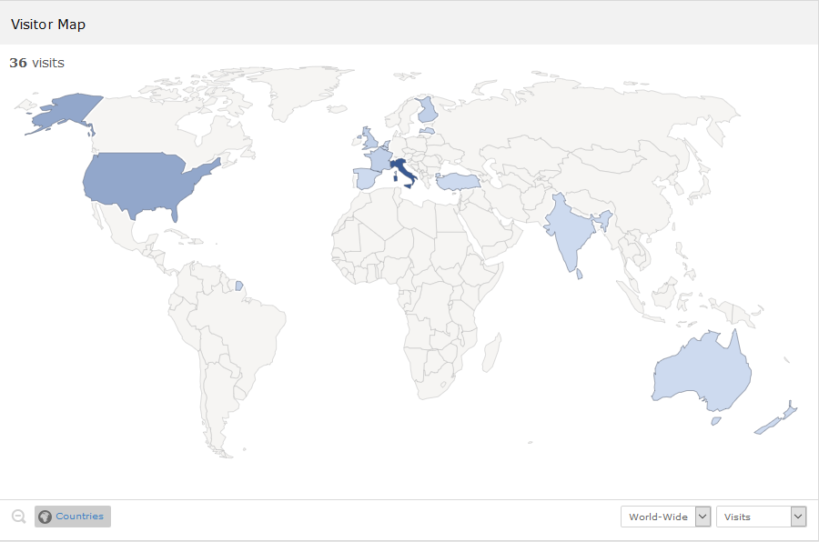

Source: PIWIK (2020, February 1).

2.3 Emphasized Paragraphs and Examples

If you want to emphasize a part of your manuscript (such as the research questions, an example or a quotation from a manager), please format it as follows:

□ Write the paragraph in italics, Times New Roman 12 pt. Alignment: justified. Indentation: left 1.5 cm; right 1.5 cm. Special: first line 0.3 cm. Single line spacing.
Begin the paragraph with a small square. Please, use the one in this example.
Leave 1 blank line before the paragraph in italics and 1 blank line after it.

2.4 Citations

In-text citations must be written in round brackets.
In-text citations are composed of the author’s surname and year of publication. In case of works by two authors, name both of them and put a “&” between their names. In case of works by three or more authors, name only the first one and add “et al.”.
If you write more in-text citations one after the other, separate each of them with a semicolon.
See the following example: (Zeyen et al., 2016; Freeman & Dmytriyev, 2017; Brondoni, 2019).
When you prepare the Bibliography (see below), please provide the extended source of each in-text citation.

2.5 Endnotes

If you need to insert a note, please use endnotes. Do not use footnotes!
Endnotes must be put after the Bibliography.
Leave 1 blank line (Times New Roman 10 pt; spacing: before 3 pt, after 3 pt; single line spacing) between the last entry of the Bibliography and the endnotes.
See the example in this document.

Bibliography

The word “Bibliography” must be written in Times New Roman 12 pt. Alignment: justified. Indentation: left 0 cm; right 0 cm. Special: none. Single line spacing.
Leave 2 blank lines (Times New Roman 12 pt, single line spacing) between your concluding section and the Bibliography.
Leave 1 blank line (Times New Roman 10 pt; spacing: before 3 pt, after 3 pt; single line spacing) between the word “Bibliography” and the first entry.

For each entry, capitalize all major words in article and journal titles, as well as in chapter and book titles.
Each entry must be formatted as follows:
- Times New Roman 10 pt;
- alignment: justified;
- indentation: left 0 cm; right 0 cm. Special: hanging 0.3 cm;
- spacing: before 3 pt, after 3 pt; single line spacing.
Moreover, provide the “doi” in the following form: http://dx.doi.org/... (do not use the form https://doi.org/... or any other forms). Write the “doi” on a separate line and format is as follows:
- Times New Roman 10 pt;
- alignment: justified;
- indentation: left 0 cm; right 0 cm. Special: first line 0.3 cm;
- spacing: before 3 pt, after 3 pt; single line spacing.

Please, when the entry consists in a Symphonya’s article, also specify the journal’s website address after the journal title. Write it in italics and in brackets. More exactly:
- write (symphonya.unimib.it) for all the articles from 2001 to 2018;
- write (symphonya.unicusano.it) for all the articles from 2019 onwards.

Please, strictly comply with all the instruction.

The following examples show you how to cite journal articles, books, book chapters and other publications.
Please, pay attention to the use of italics, capital letters, space between authors’ initials, and punctuation marks.

Boiral, O., & Heras-Saizarbitoria, I. (2017). Managing Biodiversity Through Stakeholder Involvement: Why, Who, and for What Initiatives? Journal of Business Ethics, 140(3), 403-421.
http://dx.doi.org/10.1007/s10551-015-2668-3
Brondoni, S. M. (2003). Network Culture, Performance & Corporate Responsibility. Symphonya. Emerging Issues in Management (symphonya.unimib.it), (1), 8-24.
http://dx.doi.org/10.4468/2003.1.02brondoni
Brondoni, S. M. (2018). Competitive Business Management and Global Competition. An Introduction, in Brondoni, S. M. (ed.), Competitive Business Management. A Global Perspective. New York & Turin: Routledge & Giappichelli.
Brondoni, S. M. (2019). Shareowners, Stakeholders & the Global Oversize Economy. The Coca-Cola Company Case. Symphonya. Emerging Issues in Management (symphonya.unicusano.it), (1), 16-27.
http://dx.doi.org/10.4468/2019.1.02brondoni
Brondoni, S. M., & Bosetti, L. (2018). Ouverture de ‘Integrated CSR Management’. Symphonya. Emerging Issues in Management (symphonya.unimib.it), (1), 1-17.
http://dx.doi.org/10.4468/2018.1.01ouverture
Carroll, A. B. (1999). Corporate Social Responsibility: Evolution of a Definitional Construct. Business and Society, 38(3), 268-295.
http://dx.doi.org/10.1177/000765039903800303
Clarkson, M. B. E. (1998). The Corporation and its Stakeholders: Classic and Contemporary Readings. Toronto: University of Toronto Press.
European Commission (2011). A Renewed EU Strategy 2011-14 for Corporate Social Responsibility.
Frederick, W., Post, J., & Davis, K. E. (1992). Business and Society. Corporate Strategy, Public Policy, Ethics, 7th edition. New York: McGraw-Hill.
Freeman, R. E., & Dmytriyev, S. (2017). Corporate Social Responsibility and Stakeholder Theory: Learning from Each Other. Symphonya. Emerging Issues in Management (symphonya.unimib.it), (2), 7-15.
http://dx.doi.org/10.4468/2017.1.02freeman.dmytriyev
World Business Council for Sustainable Development. (1999). Corporate Social Responsibility: Meeting Changing Expectations. Geneva.
Yin, R. K. (2003). Case Study Research: Design and Methods, 3rd edition. Thousand Oaks, CA: Sage.
Zeyen, A., Beckmann, M., & Wolters, S. (2016). Actor and Institutional Dynamics in the Development of Multi-Stakeholder Initiatives. Journal of Business Ethics, 135(2), 341-360.
http://dx.doi.org/10.1007/s10551-014-2468-1

* The Authors: Surname, N. §§ …, Surname, N. §§ …, Surname, N. §§ …
** Position, University/Firm (e-mail@e-mail.com). E.g., Full Professor of Management, Niccolò Cusano University (mario.risso@unicusano.it)
*** Position, University/Firm (e-mail@e-mail.com)
**** Position, University/Firm (e-mail@e-mail.com)
Notes Write each endnote in Times New Roman 10 pt. Alignment: justified. Indentation: left 0 cm; right 0 cm. Special: none. Spacing: before 3 pt, after 3 pt. Single line spacing.

