Manuscript Title
(It Should Not Exceed Two Lines)*

Name Surname**, Name Surname***, Name Surname****

Abstract
Please, note that the Abstract should be limited to 15 lines.
Either use the Abstract Paragraph style or write the Abstract in italics, Times New Roman 12 pt, and justify the text. Use the following indentation: left 0 cm; right 0 cm. Indent the first line of each paragraph by 0.3 cm. Use single line spacing.
Leave 2 blank lines (Times New Roman 12 pt, single line spacing) between Authors and Abstract.
Keywords: Keyword 1, Keyword 2, Keyword 3, Etc.
1. Section Title
Capitalize all major words in each section title. Please, avoid generic titles (such as “Introduction”) for Section 1.
Either use the Section Title style or comply with the following rules for the section title: Times New Roman 12 pt; bold; spacing: before 30 pt, after 10 pt; single line spacing.
The text within the section must be written in Times New Roman 12 pt and must be single-spaced. Use justified alignment. You can use the Paragraph Style.
If you don’t use the styles, please make sure to apply the following indentation for both the section title and text: left 0 cm; right 0 cm. Moreover, indent the section title line and the first line of each paragraph by 0.3 cm.
1.1 Sub-Section Title
If you need to create sub-sections, either use the Sub-Section style or comply with the following rules for the sub-section title: Times New Roman 12 pt; bold; spacing: before 18 pt, after 12 pt; single line spacing.
Capitalize all major words in the sub-section title.
The text within the sub-section must be written in Times New Roman 12 pt and must be single-spaced. Use justified alignment. You can use the Paragraph Style.
If you don’t use the styles, please make sure to apply the following indentation for both the sub-section title and text: left 0 cm; right 0 cm. Moreover, indent the sub-section title line and the first line of each paragraph by 0.3 cm.
2. Other Rules to Format the Manuscript
Please, comply with the following instructions if you need to create a bullet or numbered list, a figure or a table and if you want to emphasize something within a paragraph.
2.1 Bullet or Numbered Lists
When you create a list, please select among the following styles: Bullet List Style; Numbered List Style; Letter List Style.
Alternatively, please comply with the following rules.

To write a bullet list:
- use the same hyphen of this example;
- alignment: justified;
- indentation: left 0.3 cm; right 0 cm. Special: hanging 0.5 cm.
To write a numbered list:
- numbers must be followed by a dot, as in this example;
- alignment: justified;
- indentation: left 0.3 cm; right 0 cm. Special: hanging 0.5 cm.
To write a lettered list:
- letters must be followed by a round bracket, as in this example;
- alignment: justified;
- indentation: left 0.3 cm; right 0 cm. Special: hanging 0.5 cm.
Make sure that all numbered lists start from 1. and all lettered lists start from a).
2.2 Figures and Tables
All Figures and Tables should be inserted into the main text close to their first citation and must be numbered following their order of appearance (Figure 1, Figure 2, Table 1, Table 2, etc.).
All Figures and Tables must have a short explanatory title.
Write the title in Times New Roman 12 pt. Alignment: justified. Indentation: left 0 cm; right 0 cm; Special: first line 0.3 cm. Spacing: before 18 pt, after 10 pt. Single line spacing.
In the title line, write Figure/Table (followed by its number) in bold; then write the title in italics. Please, capitalize all major words in the title. See the examples below.
Use Times New Roman 10 pt (or less, if necessary) for the text contained in the table or figure. Use the most appropriate alignment for the text. Bold type can be used in the first row and/or column.
For each table or figure you have retrieved or adapted, you must specify the source. Please, write it in Times New Roman 10 pt. Alignment: justified. Indentation: left 0 cm; right 0 cm. Special: first line 0.3 cm. Single line spacing. Do not write anything if the table or figure is your own personal elaboration.
See the following examples.
Table 1: Complaints Regarding Breaches of Violations of Privacy
Incidents relating to privacy (no.) | 2018 | 2017 | 2016
From regulatory entities | 173 | 163 | 175
From other sources, substantiated | 191 | 29 | 14
Total substantiated complaints | 364 | 192 | 189
Source: Iberdrola (2018).
Figure 1: Symphonya Visitor Map
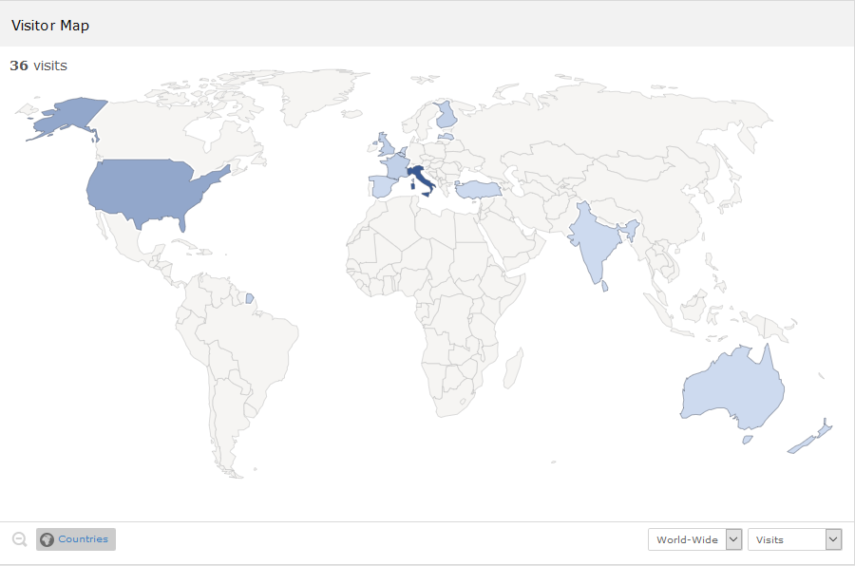
Source: PIWIK (2020, February 1).
2.3 Emphasized Paragraphs and Examples
If you want to emphasize a part of your manuscript (such as the research questions, an example or a quotation from a manager), please format it as follows:
□ Write the paragraph in italics, Times New Roman 12 pt. Alignment: justified. Indentation: left 1.5 cm; right 1.5 cm. Special: first line 0.3 cm. Single line spacing.
Begin the paragraph with a small square. Please, use the one in this example.
Use the Quotation style or leave 1 blank line before the paragraph in italics and 1 blank line after it.
2.4 Citations
In-text citations must be written in round brackets.
In-text citations are composed of the author’s surname and year of publication. In case of works by two authors, name both of them and put a “&” between their names. In case of works by three or more authors, name only the first one and add “et al.”.
If you write more in-text citations one after the other, separate each of them with a semicolon.
See the following example: (Zeyen et al., 2016; Freeman & Dmytriyev, 2017; Brondoni, 2019).
When you prepare the Bibliography (see below), please provide the extended source of each in-text citation.
2.5 Endnotes
If you need to insert a note, please use endnotes. Do not use footnotes!
Endnotes must be put after the Bibliography.
Leave 1 blank line (Times New Roman 10 pt; spacing: before 3 pt, after 3 pt; single line spacing) between the last entry of the Bibliography and the endnotes.
See the example in this document.
Bibliography
The word “Bibliography” must be written in Times New Roman 12 pt. Alignment: justified. Indentation: left 0 cm; right 0 cm. Special: none. Spacing: before 30 pt, after 20 pt. Single line spacing. Alternatively, you can use the Bibliography Title style.
For each entry, capitalize all major words in article and journal titles, as well as in chapter and book titles.
Use the Bibliography Paragraph style. Alternatively, please format each entry as follows:
- Times New Roman 10 pt;
- alignment: justified;
- indentation: left 0 cm; right 0 cm. Special: hanging 0.3 cm;
- spacing: before 3 pt, after 0 pt; single line spacing.
Moreover, provide the “doi” in the following form: http://dx.doi.org/... (do not use the form https://doi.org/... or any other forms). Write the “doi” on a separate line.
Use the DOI Bibliography style. Alternatively, comply with the following rules:
- Times New Roman 10 pt;
- alignment: justified;
- indentation: left 0 cm; right 0 cm. Special: first line 0.3 cm;
- spacing: before 0 pt, after 3 pt; single line spacing.
Please, when the entry consists in a Symphonya’s article, also specify the journal’s website address after the journal title. Write it in italics and in brackets. More exactly:
- write (symphonya.unimib.it) for all the articles from 2001 to 2018;
- write (symphonya.unicusano.it) for all the articles from 2019 onwards.
Please, strictly comply with all the instruction.
The following examples show you how to cite journal articles, books, book chapters and other publications.
Please, pay attention to the use of italics, capital letters, space between authors’ initials, and punctuation marks.

Boiral, O., & Heras-Saizarbitoria, I. (2017). Managing Biodiversity Through Stakeholder Involvement: Why, Who, and for What Initiatives? Journal of Business Ethics, 140(3), 403-421.
http://dx.doi.org/10.1007/s10551-015-2668-3
Brondoni, S. M. (2003). Network Culture, Performance & Corporate Responsibility. Symphonya. Emerging Issues in Management (symphonya.unimib.it), (1), 8-24.
http://dx.doi.org/10.4468/2003.1.02brondoni
Brondoni, S. M. (2018). Competitive Business Management and Global Competition. An Introduction, in Brondoni, S. M. (ed.), Competitive Business Management. A Global Perspective. New York & Turin: Routledge & Giappichelli.
Brondoni, S. M. (2019). Shareowners, Stakeholders & the Global Oversize Economy. The Coca-Cola Company Case. Symphonya. Emerging Issues in Management (symphonya.unicusano.it), (1), 16-27.
http://dx.doi.org/10.4468/2019.1.02brondoni
Brondoni, S. M., & Bosetti, L. (2018). Ouverture de ‘Integrated CSR Management’. Symphonya. Emerging Issues in Management (symphonya.unimib.it), (1), 1-17.
http://dx.doi.org/10.4468/2018.1.01ouverture
Carroll, A. B. (1999). Corporate Social Responsibility: Evolution of a Definitional Construct. Business and Society, 38(3), 268-295.
http://dx.doi.org/10.1177/000765039903800303
Clarkson, M. B. E. (1998). The Corporation and its Stakeholders: Classic and Contemporary Readings. Toronto: University of Toronto Press.
European Commission (2011). A Renewed EU Strategy 2011-14 for Corporate Social Responsibility.
Frederick, W., Post, J., & Davis, K. E. (1992). Business and Society. Corporate Strategy, Public Policy, Ethics, 7th edition. New York: McGraw-Hill.
Freeman, R. E., & Dmytriyev, S. (2017). Corporate Social Responsibility and Stakeholder Theory: Learning from Each Other. Symphonya. Emerging Issues in Management (symphonya.unimib.it), (2), 7-15.
http://dx.doi.org/10.4468/2017.1.02freeman.dmytriyev
Linder, J., & Cantrell, S. (2000). Changing Business Models: Surveying the Landscape. Accenture Institute for Strategic Change Working Paper. Available online: http://businessmodels.eu/images/banners/Articles/Linder_Cantrell.pdf (accessed on 3rd August 2022).
World Business Council for Sustainable Development. (1999). Corporate Social Responsibility: Meeting Changing Expectations. Geneva.
Yin, R. K. (2003). Case Study Research: Design and Methods, 3rd edition. Thousand Oaks, CA: Sage.
Zeyen, A., Beckmann, M., & Wolters, S. (2016). Actor and Institutional Dynamics in the Development of Multi-Stakeholder Initiatives. Journal of Business Ethics, 135(2), 341-360.
http://dx.doi.org/10.1007/s10551-014-2468-1

* The Authors: Surname, N. §§ …, Surname, N. §§ …, Surname, N. §§ …
** Position, University/Firm (e-mail@e-mail.com). E.g., Full Professor of Management, Niccolò Cusano University (mario.risso@unicusano.it)
*** Position, University/Firm (e-mail@e-mail.com)
**** Position, University/Firm (e-mail@e-mail.com)
Notes Use the Endnotes style. Alternatively, write each endnote in Times New Roman 10 pt. Alignment: justified. Indentation: left 0 cm; right 0 cm. Special: none. Spacing: before 3 pt, after 3 pt. Single line spacing.

